Making an Indian Shuttlecock

This is an authentic Native American toy. Children would use it to practice hunting skills.

- Lay the corn husk flat. Place the piece of clay on the husk, around one inch from the bottom and an equal distance between the left and right sides (A). Carefully fold the bottom inch of the corn husk up to cover the clay (B).
A. 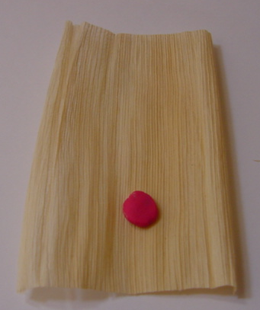 B. 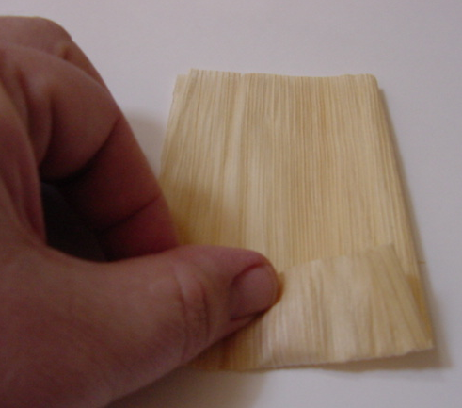
- Fold the left side of the corn husk until it reaches the middle of the husk (A), then fold the right side of the husk to the middle also (B). Then, fold the left side and right side to the middle again (C).
A. 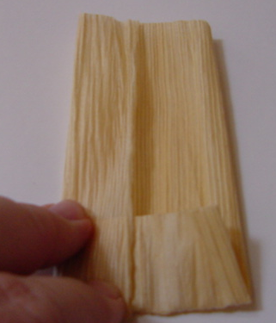 B. 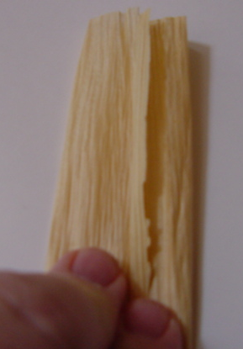 C. 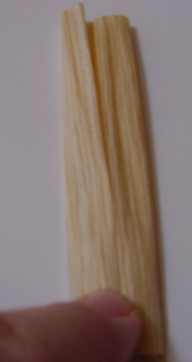
- Take two feathers and place them together, with the curved sides facing away from each other (so they make a “V” shape) (A). Insert the feathers in the top of the rolled up corn husk (B).
A. 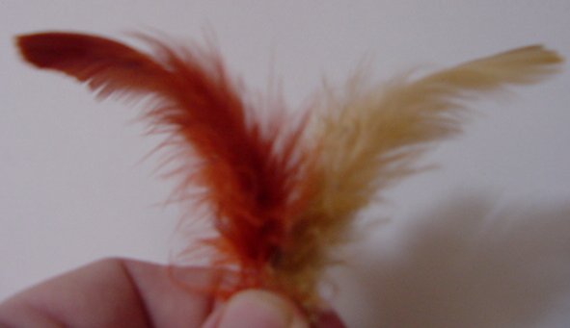 B. 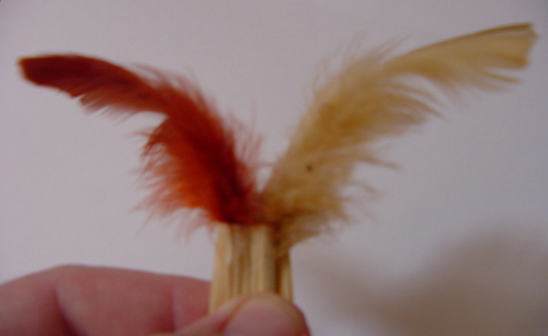
- Pinch the top of the corn husk around the feathers. Leaving an end of the string hanging out, wrap the string tightly around the top of the corn husk just below from the feathers (A). Make sure the feathers remain in place inside the husk in their “V” shape. Tie the string off to the end you left sticking out.
A. 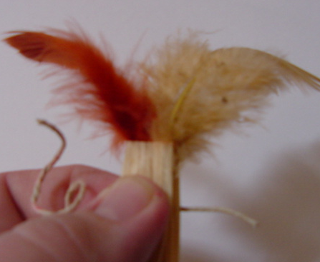 B. 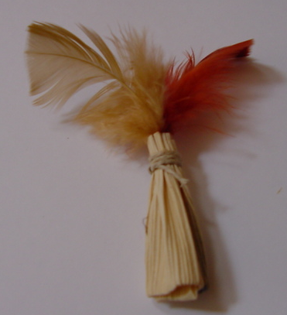

Your shuttlecock is now ready to toss. Hold it between your thumb and forefinger, then toss it like you would a paper airplane. You can also toss the shuttlecock into the air underhanded and it should “helicopter” downward. Test your skill by throwing the shuttlecock for distance and accuracy (try to toss it into a small circle, made out of rope, on the ground). Have fun!

